Classification Assignment
- Identify your problem statement?
- Problem Statement was identified as Machine Learning.
- Under Machine Learning it was a Supervised Learning since we having Input and Output Data in the Data set
- In ML we are going to User classification since it was having a Categorical Datatype(Yes/No)
- Our Prediction/Output is going to check CKD is Yes/No based on the Given Inputs
- Tell basic info about the dataset (Total number of rows, columns)
- 399 rows × 25 columns
- Mention the pre-processing method if you’re doing any (like converting string to number nominal data)
- Since it was classification Statement we need to convert the Categorical Data into Numerical Data.
- Develop a good model with good evaluation metric. You can use any machine learning algorithm; you can create many models. Finally, you have to come up with final model.
- Random Forest Classification
- Decision Tree – Classification
- SVM- Classification
- Logistic Regression
- KNN
- NVB
- Logistic Grid Classification
- SVM Grid Classification
- Decision Tree Grid Classification
- All the research values of each algorithm should be documented. (You can make tabulation or screenshot of the results.)
    - Random Forest Classification – 98%
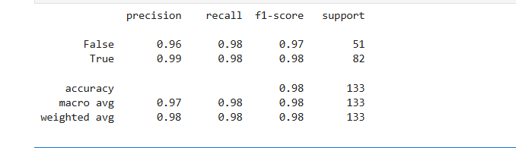
    - Decision Tree – Classification -92%
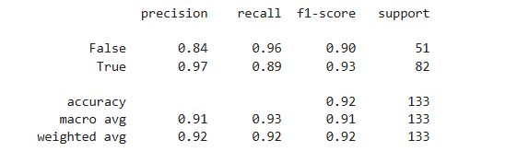
    - SVM- Classification – 62%
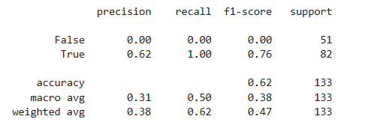
    - Logistic Regression – 89%
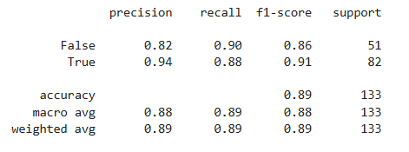

    - KNN-69%
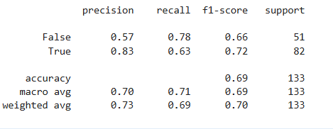
    - NB-MultinomialNB -79%
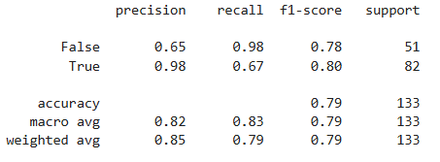
NB-
    - Logistic Grid Classification – 98%
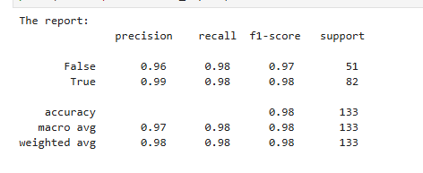
    - SVM-Grid Classification – 91%
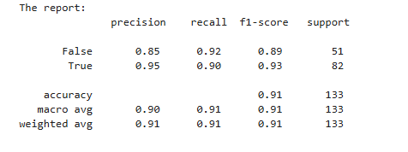
    - DecisionTree.Grid Classification – 93%
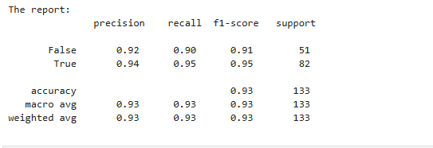
- Mention your final model, justify why u have chosen the same.
- Random Forest Classification is the Best model, since it was having best Accuracy of 98% and also compared with the data set it was providing the correct result in the Deployment phase.

